Climate Change Group update
NEW WARM HOMES GRANTS FOR 2026
Apply for fully funded, energy-efficient home improvements!
Many residents In Norfolk could now be entitled to fully funded home improvements through a new Norfolk Warm Homes Scheme.
If eligible, you can improve the energy efficiency of your home, at zero cost, helping to reduce your energy bills and keep your home warmer. All work will be carried out by council-approved contractors.
Eligibility is based on income (less than £36K p.a.) or postcode. The EPC rating of your house must be D-G. (If you don’t have a current EPC certificate, Norfolk Warm Homes will organise one for you!)
Who’s paying? The Norfolk Warm Homes Scheme is a partnership, working with local councils across Norfolk, to provide home energy efficiency improvements for eligible homeowners and private renters. Funded by the Department for Energy Security and Net Zero (DESNZ), the scheme aims to reduce energy usage, lower household bills, and cut carbon emissions.
We highly recommend that readers visit the Norfolk Warm Homes website (https://norfolkwarmhomes.org.uk) or call 01603 430103 to discuss all available options. They do answer the phone and they do call back!
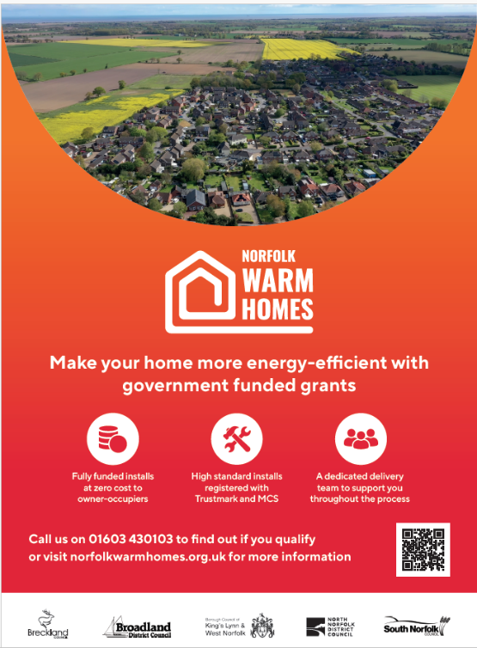
Gill Trickett

